Manuscript title; maximum 12 words; written in English; font Palatino Linotype; size 12; Bold; one space; left alignment; attract readers and convey main findings of research
(Research Subtitle; maximum 14 words; written in English; font Palatino Linotype; size 10; one space; Center alignment; attract readers and convey main findings of research)

Author¹, Jean Elikal Marna², Muhamammad Azzaki³, Ifza Ifza^{2(*)}
¹ Affiliation, City, Country,
² Dep. of Economic Education, Faculty of Economy, Universitas Negeri Padang, Padang, Indonesia,
³ Affiliation, City and Country,
^{(*)} (e-mail) ifza@fe.unp.ac.id

Abstract
Written in English; concise and factual and is able to stand alone as a unit of information. References should be avoided, but if essential, then cite the author(s) and year(s). Also, non-standard or uncommon abbreviations should be avoided, but if essential they must be defined at their first mention in the abstract itself. Typed with one space and the length of article between 100 - 200 words. If possible, avoid to contains no information not included in the paper. trade names, acronyms, abbreviations, or symbols.

Keywords: Written in English. Choosing appropriate keywords is important, because these are used for indexing purposes. Please select a maximum of 5 words to enable your manuscript to be more easily identified and cited.

Introduction
The introduction is a little different from the short and concise abstract. The reader needs to know the background to your research and, most importantly, why your research is important in this context. What critical question does your research address? Why should the reader be interested?
The purpose of the Introduction is to stimulate the reader’s interest and to provide pertinent background information necessary to understand the rest of the paper. You must summarize the problem to be addressed, give background on the subject, discuss previous research on the topic, and explain exactly what the paper will address, why, and how. A good thing to avoid is making your introduction into a minireview. There is a huge amount of literature out there, but as a scientist you should be able to pick out the things that are most relevant to your work and explain why. This shows an editor/reviewer/reader that you really understand your area of research and that you can get straight to the most important issues.
Keep your Introduction to be very concise, well structured, and inclusive of all the information needed to follow the development of your findings. Do not over-burden the reader by making the introduction too long. Get to the key parts of the paper sooner rather than later.

Literature review/ conceptual work/ Sub descriptions
Alternative: background, conceptual development or increase in conceptual work (1000-2000 words

Example below:

Table #... <Title of Table>
SMAN 1 | Program | Gender |  | ∑
 |  | Male | Female
Megang Sakti | IPA | 22 | 37 | 59
 | IPS | 21 | 38 | 59
 | Total | 43 | 75 | 118
Lubuklinggau | IPA | 19 | 47 | 66
 | IPS | 20 | 41 | 61
 | Total | 39 | 88 | 127
Total |  | 82 | 163 | 245
Table used by permission ©Sofyan, Afriyadi. 2013. Tingkat aspirasi karir siswa ditinjau dari Jenis kelamin, jurusan dan daerah tempat tinggal.

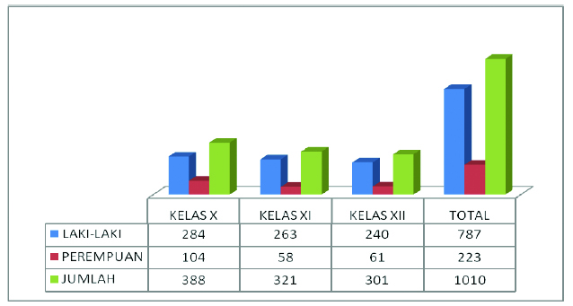

Figure # ... <Title of Figure>
Figure used by permission ©Koniaturohmah, Siti. 2016. Perbandingan antara siswa laki-laki dan siswa perempuan serta implikasinya terhadap pelayanan bimbingan dan konseling di SMK Mitra Industri MM 2100.

Conclusions
The conclusions are intended to help the reader understand why your manuscript should matter to them after they have finished reading the paper. A conclusions are not a summary of main topics, but a synthesis of key points. It is important that the conclusion does not leave the questions unanswered.
For most essays, one well-written paragraph is sufficient for conclusions, although in some cases, three paragraph conclusions may be required. Do not rewrite the abstract; do not introduce new arguments, evidence, new ideas, or information unrelated to the topic; do not include evidence (quotations, statistics, etc.) that should be in the body of the paper.

References
References should follow the style detailed in the APA 6th Publication Manual. Make sure that all references mentioned in the text are listed in the reference section and vice versa, and that the spelling of author names and years are consistent. Please to not be used footnote or endnote in any format.

Best Practice:
Please cross check for:
- Spelling of author names;
- Punctuation;
- Number of authors to include before using “et al.”, and;
- Reference style.

We suggest all of you using software MENDELEY, ZOTERO, or ENDNOTE for easily citation. References should be the most recent and pertinent literature available (about 5-10 years ago).
Mastercard. (2013). Two thirds of Asia/Pacific parents spending on extra tuition for kids: MasterCard survey. Retrieved from http://newsroom.mastercard.com/press-releases/two-thirdsofasiapacific-parents-spending-on-extra-tuition-for-kids-mastercard-survey/
Nath, Samir Ranjan. (2008). Private supplementary tutoring among primary students in Bangladesh.Educational Studies, 34(1), 55-72, DOI: 10.1080/03055690701785285.
Purwanto, M. Ngalim. (2007). Psikologi Pendidikan. Bandung: Remadja Rosdakarya Offset.
Republic of Indonesia. Law No. 20 Year 2003 on National Education System.

Petunjuk Penulisan secara rinci bisa Author lihat pada Template di atas, berikut merupakan petunjuk umum
- Jenis huruf Palatino Linotype
- Abstrak terdiri dari 100-250 kata
- Keseluruahan Paper dari judul hingga daftar pustaka terdiri dari 3000-5000 kata
- Menyinggung tema conference “sustainable Innovation in The Digital Era” pada bagian introduction
- Awal paragraph menjorok 0,5 Cm
- Spacing antar paragraph adalah 6 pt, lihat gambar dibawah ini
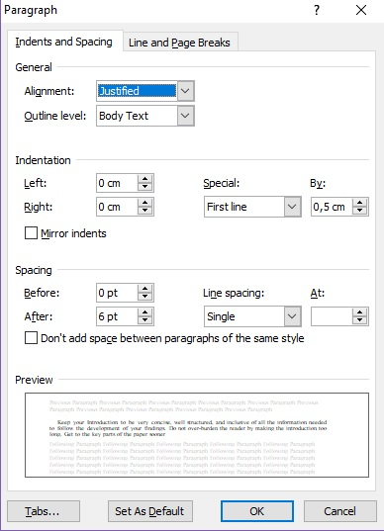
- Tabel:
- Judul Tabel ditulis di atas tabel
- Judul Tabel TIDAK BOLD (TEBAL)
- Tabel hanya diberi garis horizontal
- Sumber tabel atau copyright di tulis di bawah tabel dengan ukuran huruf 6
- Judul Gambar ditulis dibagain bawah gambar , TIDAK bold

